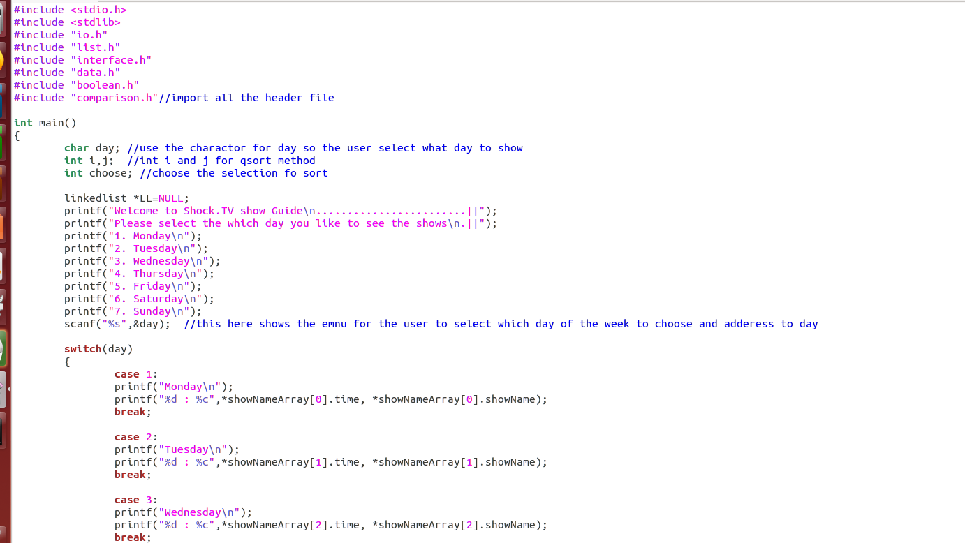

Figure 1.1 is the beginning of the main() name of the file tvguide.c

In this is a main file main() of figure 1. In this main file called tvguide.c shows the output UI to show the user to select the day of the week. To use that use Switch case method to select the the day of the week. When the User select the day to the week the output will show the time and the name of the shows of that particular day. (CodeofWin 2018)

Example if the User select Monday he type Monday. After that output of the showNameArray[i].time is the time of that show on Monday and showNameArray[i].showName is the name of the shows on Monday. (qsort() — Sort Array IBM Knowlege Centre n.d.)

Figure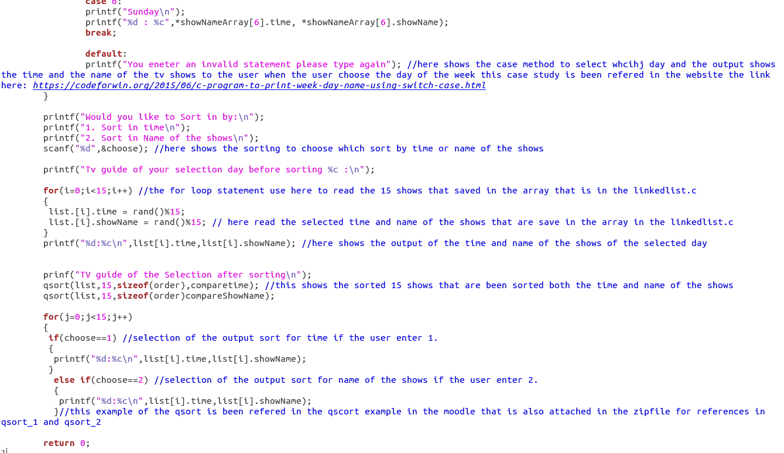1.2 is the continueation of the main and the end of the main file with return 0 because the main is in int main()

If the User input/type the wrong file, an error occurred in the default adter the case Sunday as shown the figure above. (Chong, Moodle 2018)

When the User selected the day of the week in the the next step shows the shich sort would the user choose to sort by time or by name of the shows. When the User choose 1 it sorted the time from 0.00 till 23.00. if the user choose to sort the name of the shows, the user press 2 so that the sort the name of the shows from A to Z. (Yu 2017)

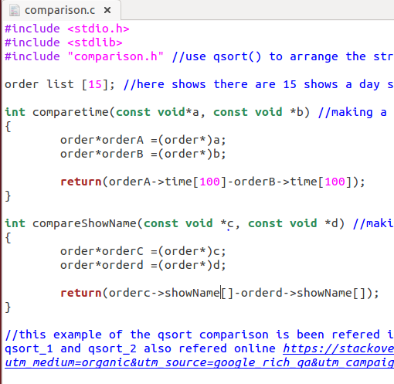

Figure 2.1 shows the comaprion.c

In the Comparison.c the functuion comparetime amd compareShowName is to sort the name of the shows each of time and name of the shows. Qscort method is used to scort both the time and name of the shows from 0.00 and 23.00 and name formA to Z. (Chong, Moodle 2018)

Order it pointed to time and name of the show in the array that is stored in the linkedlist.c.

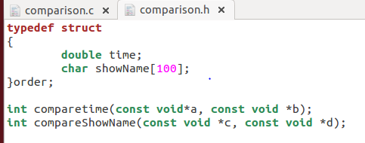Figure 2.2 shows the comparison.h

In the comparison.h the order is in the main fileso it is sorted by order.

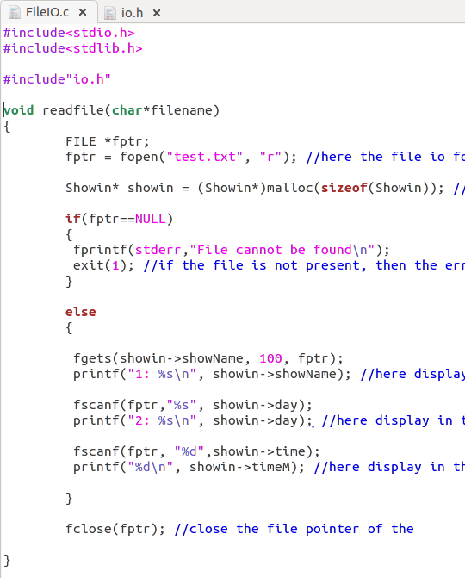

Figure 3.1 shows the File i/o of read function

In the file io, the function readfile is created to read the data in the test.txt file. Using the filepointer, pointed which (UCP COMP1000 Test 2 2017) file and size of the function were created. And if statement one for error if the file cannot be found and the other is to show the data in the UI. If the error statement have not execute, it move to the else statement where it output in the UI of list of shows time and day. (Chong, UCP COMP1000 2016)

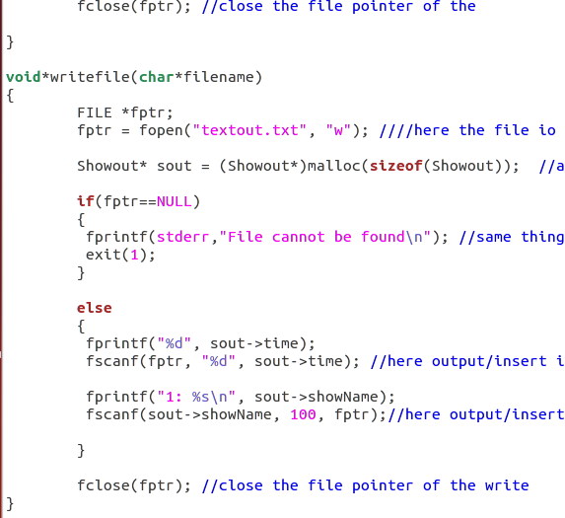

Figure 3.2 show the function for writefile in the same FileIO.c

The function writefile is where the all the input from the frist text file “test.txt” is move into the another text file called textout.txt. (Tutorialpoints 2018)Same command if the file got an error it shows the first if statement if not it execute on the second else statement where the results are stored in the second textfile “textout.txt” fileclose the file pointer. (Chong, Moodle 2018)

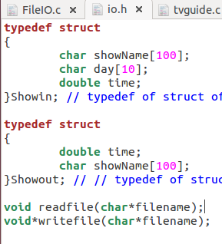 Figure 3.3 shows the header file for fileIo called io.h

In the io.h header of FileIO.c, where are two typedef struct one is for showin for extract the file and the other is showout for output the data and insert in the output textfile.

Figure 4.1 shows the linkedlist.c for function name Insert element. 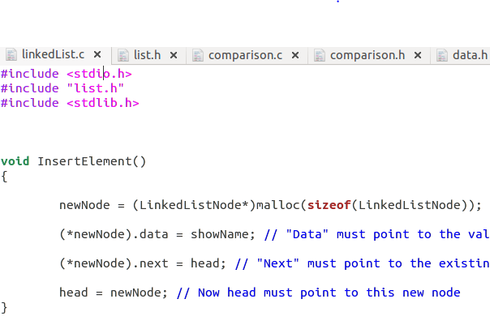

In the figure is the function called insertElement to create the size of the linked list of the new node. First to Create a new node and next the data must point to the value to be inserted next “Next” must point to the existing first node and lastly the head must point to this new node

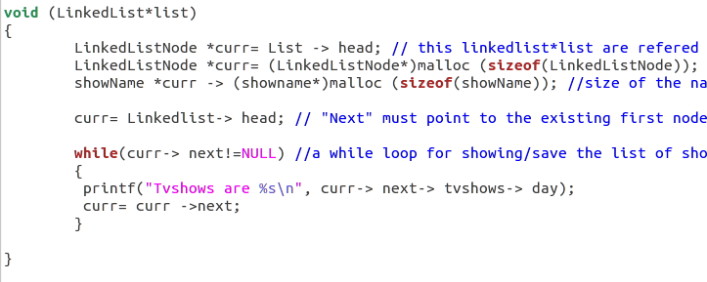

Figure 4.2 shows the function called LinkedList*list where a while loop statement is to show the data that are stored name and time of the shows of the day that the user select the day.

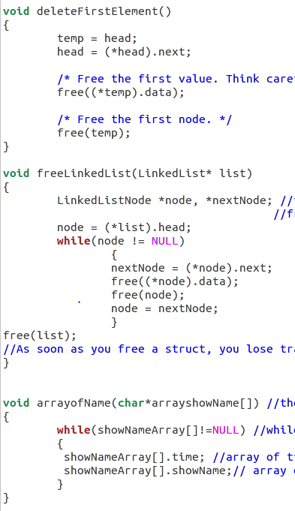Figure 4.3 shows the fuction for Delete, Freelinkedlist and arrayofName

The first function deleteFunctionElement is to delete data of the firstnode. Second is the freelinkedList To deal locate a linked list, first must free each node; then free the main list struct the cross the list while removing it. It is done carefully, in a scrupulous order easily to create memory leaks here Then free a struct, lose track of its inside including any pointers. In this use Iterativity the last is the Array of Struct where all the data of time and name of the shows is been stored from the linked list to array of struct. (UCP 2015 Lecture 06 Structs 2015)

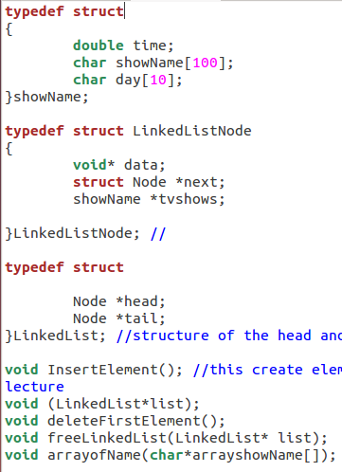

Figure 4.4 shows the header file for linked list called list.h

In the header file for linkedlist made three typedefs one is to increment for time name of the shows and day of the week. The other is ti create a linklist node for struct node name. and the last is the linkedlist struct ofr head and tail node. And other 4 are the functions elements (UCP 2015 Lecture 06 Structs 2015)

# References

1.Chong, Dr. Ling Huo. *Moodle.* April 18, 2018. http://moodle.curtin.edu.my/mod/folder/view.php?id=93640 (accessed May 1, 2018).

—. *UCP COMP1000.* Miri: Curtin Moodle, 2016.

*CodeofWin.* 2018. https://codeforwin.org/2015/06/c-program-to-print-week-day-name-using-switch-case.html (accessed May 15, 2018).

*qsort() — Sort Array IBM Knowlege Centre.* https://www.ibm.com/support/knowledgecenter/en/ssw_ibm_i_72/rtref/qsort.htm (accessed May 20, 2018).

*Tutorialpoints.* 2018. https://www.tutorialspoint.com/cprogramming/c_file_io.htm (accessed 2018).

"UCP 2015 Lecture 06 Structs." 26-61. Curtin University, Perth: Dr. Ling Huo Chong, 2015.

"UCP COMP1000 Test 2." In *UCP COMP1000 Test 2*, Question 4. Curtin University, Perth: Dr. Ling Huo Chong, 2017.

Yu, Peter. *Stack overflow.* September 12, 2017. https://stackoverflow.com/questions/46186138/how-to-use-qsort-in-an-array-structure-in-c-language?utm_medium=organic&utm_source=google_rich_qa&utm_campaign=google_rich_qa (accessed May 24, 2018).

Curtin University – Department of Computing **Declaration of Originality**

You must fill out, sign and submit this declaration to the lecturer/unit coordinator **in person**, or your assignment will receive zero marks.  **Please print clearly** *.*

|  |  |  |  |
| --- | --- | --- | --- |
| Family name: | Puthhuppully | Student ID: | 15901758 |
| Given name(s): | Ashok Mohan | | |
| Unit name: | Unix and C Programming | Unit ID: | COMP1000 |
| Lecturer: | Dr. Ling Huo Chong | Tutor: | Dr. Ling Huo Chong  Mr. Veeramani |
| Date of submission: | 28/5/2018 8am. | | |

I declare that:

* The above information is complete and accurate.
* The work I am submitting is *entirely my own*, except where clearly indicated otherwise and correctly referenced.
* I have taken (and will continue to take) all reasonable steps to ensure my work is *not accessible* to any other students who may gain unfair advantage from it.
* I have *not previously submitted* this work for any other unit, whether at Curtin University or elsewhere, or for prior attempts at this unit, except where clearly indicated otherwise.

I understand that:

* Plagiarism and collusion are dishonest, and unfair to all other students.
* If I plagiarise or collude, I risk failing the unit with a grade of ANN (“Result Annulled due to Academic Misconduct”), which will remain permanently on my academic record. I also risk termination from my course and other penalties.
* Plagiarism and collusion may be detected manually or by means of tools (such as Turnitin).
* Even with correct referencing, my submission will only be marked according to what I have done myself, specifically for this assessment. I cannot re-use the work of others, or my own previously submitted work, in order to fulfil the assessment requirements.
* It is my responsibility to check that any files I submit are readable and not corrupted.

Signature: ____________________________________________________________ Date: ________________________________